3GPP TSG RAN WG1 #125 R1-2604898
Dalian, China, May 18th - 22nd, 2026
Agenda item: 10.8.2
Source: Jio Platforms Ltd.
Title: Views on aspects of integration with communication
Document for: Discussion and Decision

1. Introduction
This document provides views on integration with communication for 6G ISAC, with the main view that compact, low-latency sensing measurement reporting to the aNB is needed for sensing-assisted beam management and related radio adaptation.

Agreement:
- On measurement for ISAC, study at least the following aspects.
  - Measurement definitions/levels for TRP-side measurement, taking the measurement Levels studied in NR ISAC as starting point
  - Measurement definitions/levels for UE-side measurement
  - Impacts of non-ideal factors on measurement
  - Other aspects are not precluded
  - Note: this discussion may or may not mean there is specification impact

Agreement:
- On measurement report for ISAC, study at least the following aspects and applicable scenarios (e.g., sensing modes, targets, etc.) from RAN1 perspective.
  - Measurement reporting mechanism from UE
    - Option 1A: The UE measurements and/or assistance information if needed from UE can be directly sent to aNB
    - Option 1B: The UE measurements and/or assistance information if needed from UE can be sent to SF
  - Measurement reporting mechanism from aNB
    - Option 2A: The aNB measurements and/or assistance information if needed from aNB can be directly sent to UE
    - Option 2B: The aNB measurements and/or assistance information if needed from aNB can be sent to SF
  - The study may require cross-WG coordination.
  - Note: combination of multiple options is not precluded.
  - Note: measurements in each option may be different

Agreement:
- On measurement report for ISAC, study impacts from at least the following aspects from RAN1 perspective
  - Measurement reporting mechanism
    - E.g., Periodic, semi-persistent, aperiodic, event-triggered report as starting point
    - Reporting signaling e.g., L1, L2, higher layer, etc.
  - Other aspects are not precluded
  - The study may require cross-WG coordination.
Agreement:
- On RS for ISAC, study at least the following aspects, considering sensing performance, resource overhead and impact to communication
  - RS for communication is reused for sensing
  - Enhanced RS for sensing, taking reuse of RS for communication as starting point
    - Note: Part of or all of the RS may be used for communication purpose, and it does not mean the final decision on whether the enhanced RS is used for communication purpose is to be made in this agenda.
  - Dedicated RS for sensing

Agreement:
- Study RE patterns of RS for sensing, considering sensing performance, resource overhead and impact to communication
- Note: enhancements on RS sequence if any will be discussed in agenda 10.8.3
Agreement:
- On measurement for ISAC, study at least the following aspects.
  - Measurement definitions/levels for TRP-side measurement, taking the measurement Levels studied in NR ISAC as starting point
  - Measurement definitions/levels for UE-side measurement
  - Impacts of non-ideal factors on measurement
  - Other aspects are not precluded
  - Note: this discussion may or may not mean there is specification impact

Agreement:
- On measurement report for ISAC, study at least the following aspects and applicable scenarios (e.g., sensing modes, targets, etc.) from RAN1 perspective.
  - Measurement reporting mechanism from UE
    - Option 1A: The UE measurements and/or assistance information if needed from UE can be directly sent to aNB
    - Option 1B: The UE measurements and/or assistance information if needed from UE can be sent to SF
  - Measurement reporting mechanism from aNB
    - Option 2A: The aNB measurements and/or assistance information if needed from aNB can be directly sent to UE
    - Option 2B: The aNB measurements and/or assistance information if needed from aNB can be sent to SF
  - The study may require cross-WG coordination.
  - Note: combination of multiple options is not precluded.
  - Note: measurements in each option may be different

Agreement:
- On measurement report for ISAC, study impacts from at least the following aspects from RAN1 perspective
  - Measurement reporting mechanism
    - E.g., Periodic, semi-persistent, aperiodic, event-triggered report as starting point
    - Reporting signaling e.g., L1, L2, higher layer, etc.
  - Other aspects are not precluded
  - The study may require cross-WG coordination.

2. Discussion

2.1 Simulation methodology used for the views in this document
The issue with several candidate integration options is that they may appear attractive when considered qualitatively, but their suitability changes when reporting latency, resource overhead, sensing reliability, communication impact and non-ideal radio effects are jointly considered. Therefore, the views in this document are based on simulation-driven analysis using a common evaluation approach across the relevant topics. The simulations are not intended to define 6G requirements. They are used to compare candidate design options and to identify which options are suitable for further RAN1 study.
For sensing-assisted communication, sensing-side performance alone is not sufficient. A sensing measurement with low range or velocity error is useful for communication only if it can be reported and acted upon before the relevant radio condition changes. Similarly, communication throughput alone is not sufficient, because the radio action must be based on a reliable sensing measurement. Therefore, we evaluate both sensing-side and communication-side metrics, including beam failure probability, reporting latency, range RMSE, velocity RMSE, detection probability, false action probability, RS overhead, report overhead and victim communication outage.
For a communication-assistance feature, the useful gain can be represented by a joint utility metric
$$J=a_{1}G_{BF}+a_{2}G_{lat}+a_{3}G_{TP}-a_{4}O_{RS}-a_{5}O_{rep}-a_{6}P_{false}-a_{7}P_{outage},$$
where $G_{BF}$denotes beam-failure reduction, $G_{lat}$denotes radio-action latency reduction, $G_{TP}$denotes communication throughput gain, $O_{RS}$denotes sensing/communication RS overhead, $O_{rep}$denotes sensing report overhead, $P_{false}$denotes false radio-action probability due to incorrect or stale sensing information, and $P_{outage}$denotes victim communication outage probability. The weighting factors $a_{i}$can be selected according to the evaluated use case. This formulation makes the trade-off explicit: a sensing mechanism is not preferred only because it improves sensing accuracy; it should also provide communication benefit within acceptable overhead and reliability limits.
The simulation set includes six cases. S1 evaluates reporting latency and compares direct compact UE-to-aNB reporting with indirect or richer reporting paths. S2 evaluates sensing-assisted beam management under dynamic blockage and reflected-path conditions. S3 evaluates sensing RS RE patterns, including uniform and non-uniform frequency-domain patterns and their impact on range ambiguity and overhead. S4 evaluates CPI duration, Doppler estimation and discontinuities caused by timing, power, beam or frequency changes. S5 evaluates sensing-aware power control and power limitation effects for sensing RS transmission. S6 evaluates sensing interference mitigation, including sensing-to-communication and sensing-to-sensing interference. Figure 2.1-3 summarizes how these simulation cases are mapped to the key evaluation metrics used in this document.
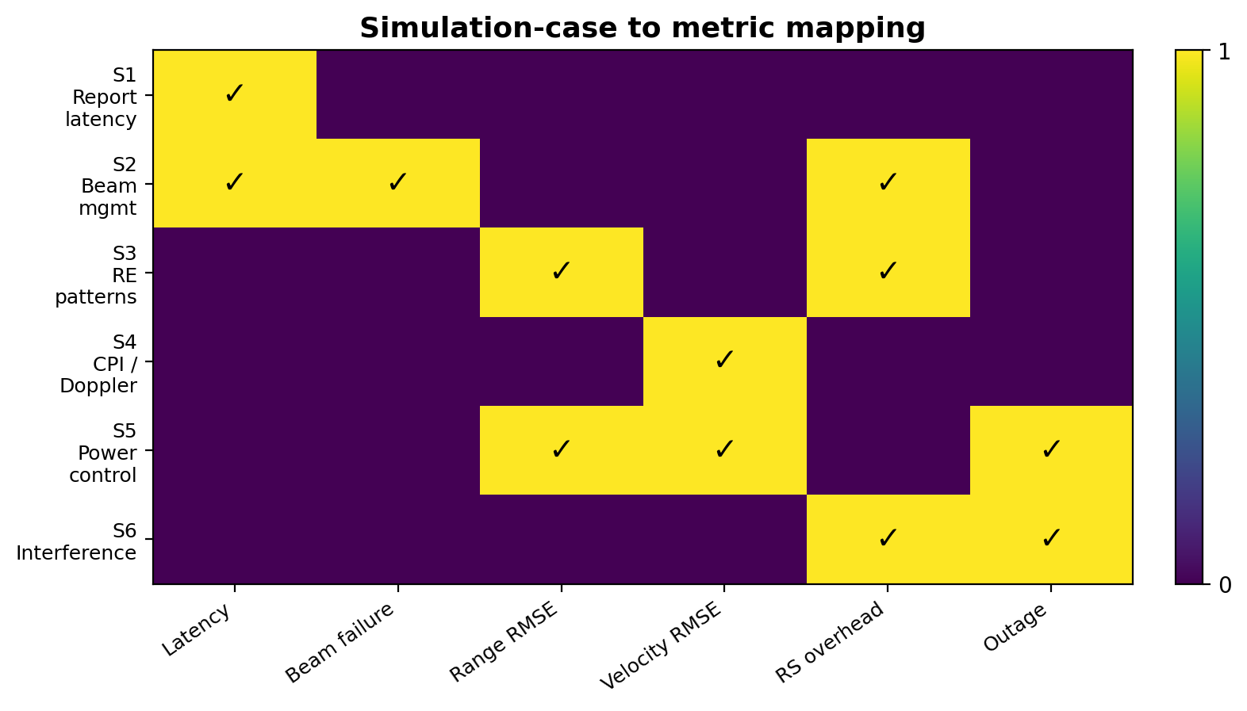
Figure 2.1-3: Mapping between simulation cases and evaluation metrics.
Observation 2: A joint sensing-communication evaluation is necessary for 10.8.2 because a sensing option that improves range, velocity or detection performance may still be unsuitable if it increases reporting latency, RS/report overhead, false radio-action probability or communication outage.
Proposal 2: RAN1 should evaluate sensing-assisted communication features using both sensing-side and communication-side metrics, including at least reporting latency, sensing accuracy, detection probability, communication performance impact, RS/report overhead, false radio-action probability and victim communication outage.

2.2 Compact sensing information
The issue is that sensing reports used for communication assistance have a different latency and content requirement compared with sensing reports used for non-real-time sensing fusion. If UE sensing measurements are routed only to the SF, the aNB may receive the result too late to update beam/TCI state, CSI-RS resources, scheduling decisions or sensing resource activation. Conversely, if the UE is required to report raw sensing data or rich sensing profiles directly to the aNB, the uplink report overhead and UE processing burden can become excessive. Therefore, the suitable design point is not raw aNB reporting or SF-only reporting, but compact aNB-visible sensing information for radio adaptation, with optional richer reporting to the SF for sensing fusion.
The aNB is the appropriate endpoint for low-latency communication assistance because it controls the radio actions that must be taken within a short time budget. These actions include beam/TCI update, CSI-RS activation, PDCCH/PDSCH/PUSCH scheduling, power configuration, collision handling and sensing resource activation. The SF remains useful for multi-node fusion, object-level processing and longer-term sensing services. Therefore, both endpoints should remain in the study, but the report content and latency class should depend on the endpoint and the purpose of the report.
For a sensing report to be useful for proactive radio adaptation, the total time from measurement to radio action should satisfy
$$T_{total}=T_{meas}+T_{report}+T_{proc}+T_{action}<T_{deg},$$where $T_{meas}$is the time required to obtain the sensing measurement, $T_{report}$is the report delivery time, $T_{proc}$is the aNB processing time, $T_{action}$is the time required to apply the radio action, and $T_{deg}$is the time before the relevant communication state becomes degraded. For sensing-assisted beam management, $T_{deg}$corresponds to the time before serving beam degradation, blockage impact, or invalidation of the current beam/TCI assumption. If the reporting path makes $T_{total}>T_{deg}$, the sensing result may still be useful for sensing fusion, but it is no longer useful for proactive beam management.
In simulation case S1, three reporting paths are evaluated. The direct compact UE-to-aNB reporting path gives a median latency of 3.4 ms and 95%-ile latency of 5.6 ms. The split reporting path, where compact information is provided to the aNB and richer information is also made available to the SF, gives a median latency of 12.6 ms and 95%-ile latency of 18.9 ms for the richer path. The indirect UE-to-SF-to-aNB path gives a median latency of 41.8 ms and 95%-ile latency of 68.5 ms. As shown in Figure 2.3-1, the indirect SF-routed path exceeds a typical low-latency radio-action budget and is therefore not suitable as the only path for sensing-assisted beam management.
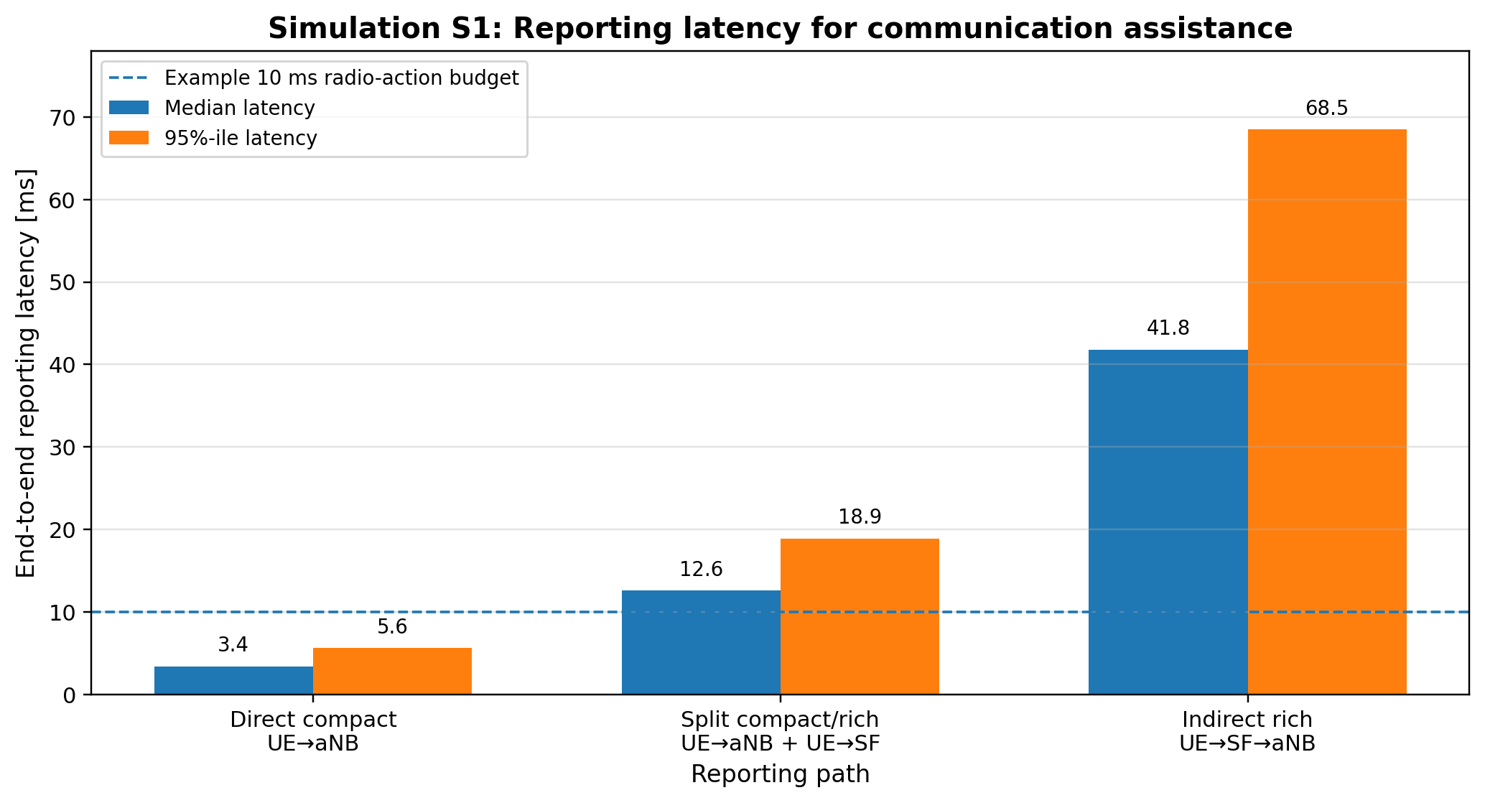
Figure 2.2-1: Simulation S1 reporting latency for communication assistance.
The result indicates that the reporting architecture should be purpose dependent. For low-latency beam management, the aNB should receive a compact report containing only communication-actionable information, such as impacted beam/TCI, recommended backup beam/TCI, confidence, validity time and time-to-impact. For SF-oriented sensing fusion, richer reports may be provided with relaxed latency requirements. This split avoids forcing the aNB to receive raw or rich sensing data while also avoiding the latency penalty of SF-only reporting.
Observation 3: For sensing-assisted communication, compact aNB-visible sensing reporting is needed because SF-only reporting can exceed the radio adaptation time budget, while raw or rich aNB reporting can create excessive UE processing and uplink overhead.
Proposal 3: RAN1 should study direct reporting of compact communication-assistance sensing information to aNB, with optional richer reporting to SF for non-real-time sensing fusion

2.3 Procedure among UE, aNB and SF for sensing-assisted communication
The issue is that sensing-assisted communication requires radio-timed operation, whereas sensing-service operation may tolerate a longer processing and reporting delay. If sensing RS configuration, sensing report configuration and report delivery are not visible to the aNB, then semi-persistent or aperiodic sensing operation becomes difficult to align with beam state, CSI-RS activation, scheduling load and resource collision handling. In particular, if the SF directly controls low-latency sensing resources without timely aNB involvement, the delay between SF processing and aNB radio action may prevent proactive beam/CSI adaptation.
There are three possible procedure options. In the first option, UE sensing measurements are routed mainly to the SF, and the SF later provides processed information for communication adaptation. This option is suitable for richer sensing fusion and longer-term sensing services, but it is not suitable as the only path for fast radio adaptation because the aNB may receive the information after the beam or scheduling condition has already changed. In the second option, raw or rich sensing measurements are reported directly to the aNB. This can reduce endpoint delay, but it increases UE processing and uplink reporting overhead and may provide more information than the aNB requires for immediate radio action. In the third option, the aNB configures radio-facing sensing resources and receives compact communication-assistance information directly, while richer information may also be sent to the SF when needed. In our view, the third option provides the best balance for sensing-assisted communication.
For UE-involved sensing-assisted communication, the aNB should configure the radio-facing sensing RS resources, measurement request and report configuration because the aNB has immediate visibility of scheduling, beam state, communication load and resource collision conditions. The SF can request a sensing task or receive richer sensing results, but the aNB should control the radio resources used for low-latency communication assistance. This is especially important for sensing-assisted beam management, where the sensing report and beam/TCI action are tightly coupled.
The sensing configuration can be represented as
$$C_{sense}=\left\{R_{RS} , Q_{meas} , P_{purpose} , E_{endpoint} , L_{class} , T_{trigger} , P_{priority}\right\},$$where $R_{RS}$denotes the sensing RS resource configuration, $Q_{meas}$denotes the requested measurement quantity, $P_{purpose}$denotes the report purpose, $E_{endpoint}$denotes the configured report endpoint, $L_{class}$denotes the latency class, $T_{trigger}$denotes the reporting trigger, and $P_{priority}$denotes the collision or activation priority. The UE generates a report only when the configured purpose and trigger condition are satisfied. If the configured endpoint includes the aNB, the aNB consumes the compact report directly for radio adaptation. If the configured endpoint also includes the SF, richer sensing information may be provided for non-real-time fusion or sensing-service processing.
For beam assistance, the compact report should contain only the information needed for radio action, such as impacted beam/TCI, recommended backup beam/TCI, confidence, validity time and time-to-impact. After receiving this report, the aNB can update candidate beam/TCI state, activate or reconfigure CSI-RS resources, and provide the scheduler with the required beam/CSI control input. The scheduler can then adapt PDCCH/PDSCH/PUSCH scheduling, RS resources or beam indication based on the updated radio state.
Figure 2.4-1 shows the preferred procedure. The UE is configured with sensing capability and report configuration. The aNB provides the sensing RS measurement request. When the trigger condition is met, the UE sends a compact beam impact report to the aNB. If needed, richer sensing data may be forwarded to the SF. The aNB then updates the beam/CSI control function and scheduler adaptation before sending updated sensing RS or beam indication to the UE.
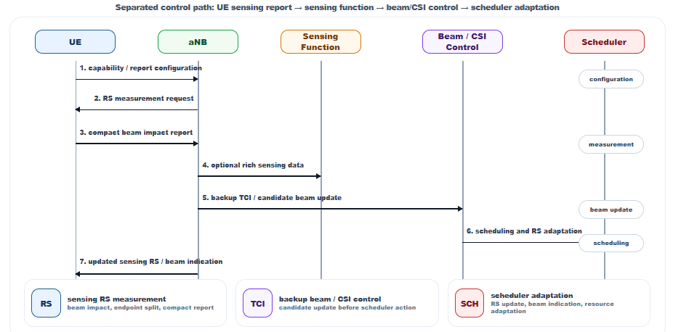
Figure 2.3-1: Procedure among UE, aNB and SF for sensing-assisted communication
The simulation results in S1 and S2 show that the same sensing measurement can be useful or useless depending on whether the report reaches the aNB before the beam degradation deadline. Therefore, the procedure should be designed according to radio-action timing, not only sensing-service timing. This supports a procedure where the aNB controls radio-facing sensing configuration and receives compact communication-assistance reporting directly, while the SF remains available for richer sensing processing.
Observation 4: For UE-involved sensing-assisted communication, aNB-controlled radio configuration and compact aNB-visible reporting provide better support for low-latency beam/CSI adaptation than SF-only configuration and reporting.
Proposal 4: RAN1 should study a UE-aNB procedure for communication assistance, including sensing RS configuration, measurement request, report configuration, reporting trigger, endpoint/latency-class indication and compact UE-to-aNB sensing measurement reporting.

2.4 Sensing-assisted communication
Sensing-assisted communication can potentially support several communication procedures, including beam management, CSI acquisition, mobility support, resource allocation, power saving and RACH assistance. However, if all possible procedures are studied at the same level of detail from the beginning, the study may lose focus. In our view, the first detailed use case should satisfy three conditions: the sensing input should be clearly identifiable, the communication action should be radio-facing, and the gain should be measurable using both sensing-side and communication-side metrics.
Beam management satisfies these conditions more directly than other candidate use cases. A sensed moving object, reflector or blockage can be translated into a beam/TCI impact. Based on this information, the aNB can restrict the candidate beam set, select or prepare a backup beam, activate additional CSI-RS resources, reduce unnecessary beam sweeping, or prepare beam failure recovery. These actions are PHY-layer or scheduler-facing radio actions and therefore have direct relevance for RAN1.
The issue with communication-only beam management is that it is mainly reactive. The serving beam is normally changed after communication measurements indicate degradation. This creates a delay due to measurement, filtering, reporting, network decision and beam/TCI update. Increasing periodic beam sweeping can reduce the reaction delay, but it increases CSI-RS overhead and UE measurement burden. Sensing can provide an earlier indication because the environmental cause of beam degradation can be detected before the communication beam itself collapses.
The beam-impact trigger can be represented as
$$triggerifP_{impact}(b,t+Δt)>P_{th}andC_{meas}>C_{th},$$where $b$denotes the current beam or TCI state, $P_{impact}(b,t+Δt)$denotes the predicted probability that the beam or TCI state will be impacted after time $Δt$, $P_{th}$denotes the configured impact threshold, $C_{meas}$denotes the confidence of the sensing measurement, and $C_{th}$denotes the configured confidence threshold. This avoids acting on low-confidence sensing information and reduces the risk of unnecessary beam switching.
The resulting beam-management action can be represented as
$$b_{backup}^{*}=arg⁡\underset{b^{'}∈B_{cand}}{max⁡}\left[G(b^{'})-λ_{1}P_{impact}(b^{'},t+Δt)+λ_{2}C(b^{'})-λ_{3}O(b^{'})\right],$$where $B_{cand}$is the candidate backup beam set, $G(b^{'})$is the expected beam gain, $P_{impact}(b^{'},t+Δt)$is the predicted impact probability for candidate beam $b^{'}$, $C(b^{'})$is the confidence associated with the candidate beam, and $O(b^{'})$is the measurement or switching overhead. This formulation shows that the preferred backup beam is not selected only by current received power; it should also consider predicted blockage/impact, confidence and overhead.
In simulation case S2, three beam-management options are compared: communication-only reactive beam management, enhanced periodic sweep, and sensing-assisted beam management. Communication-only reactive beam management has the highest beam failure probability because it reacts after the communication measurement degrades. Enhanced periodic sweep reduces beam failure probability by increasing measurement opportunities, but it requires higher CSI-RS overhead. The proposed sensing-assisted beam management provides earlier beam-impact information and restricts the beam action to the relevant candidate set.
As shown in Figure 2.6-1, at blocker density of 3 objects/1000 m${}^{2}$, communication-only reactive beam management gives beam failure probability of 5.8%, enhanced periodic sweep gives 4.3%, and sensing-assisted beam management gives 1.9%. At blocker density of 5 objects/1000 m${}^{2}$, the corresponding beam failure probabilities are 12.6%, 9.8% and 3.8%. This indicates that sensing-assisted beam management provides a larger reliability gain as the environment becomes more dynamic.
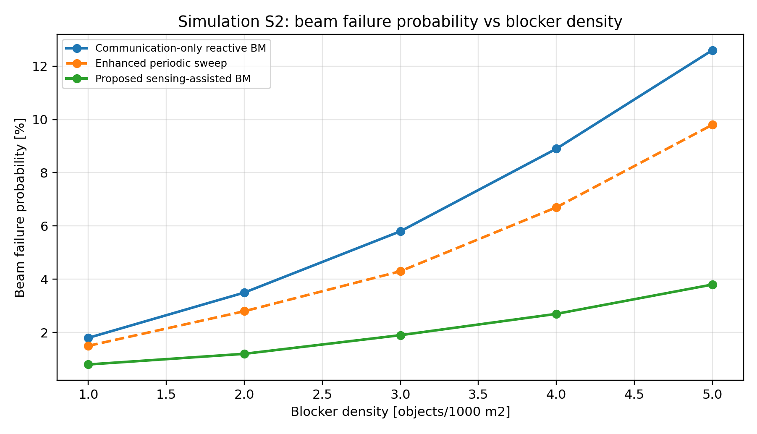
Figure 2.4-1: Simulation S2 beam failure probability versus blocker density.
The result supports using beam management as the first detailed sensing-assisted communication use case. It has a clear sensing input, namely predicted beam impact due to blockage, reflection or moving objects. It has a clear radio output, namely candidate beam restriction, backup beam/TCI preparation, CSI-RS activation or beam failure recovery preparation. It also has measurable benefits in terms of beam failure probability, beam-application latency and CSI-RS overhead.
Observation 6: Beam management is the most suitable first use case for sensing-assisted communication because both the sensing input and the communication action are radio-facing, low-latency and measurable using beam failure probability, CSI-RS overhead and beam-action latency.
Proposal 6: RAN1 should study sensing-assisted beam management as the primary usage scenario for communication assistance, including required sensing measurements, compact report content, confidence/validity information, candidate beam restriction, backup beam/TCI preparation and PHY-layer impact.

2.5 Communication-only beam management under dynamic blockage
The issue with communication-only beam management is that the network normally reacts after the communication beam quality has already degraded. The reaction time includes beam measurement, filtering, report triggering, network decision, beam/TCI update and scheduler adaptation. For a fast blocker, narrow high-frequency beam or rapidly changing reflection condition, the serving beam may become unusable before the new beam is ready. One option is to reduce this delay by increasing periodic beam sweeping. However, this increases CSI-RS overhead and UE measurement burden, and the additional sweeping is applied even when no blockage event occurs.
Sensing provides different information compared with communication-only beam measurement. Communication measurement indicates that the serving beam is already degraded or becoming degraded. Sensing can detect the environmental cause of future degradation, such as a moving object crossing the beam, a reflector disappearing, or a blockage approaching the serving path. Therefore, the main value of sensing-assisted beam management is not only improved estimation accuracy; the main value is earlier timing. The report should therefore not be a generic object report. For beam management, the useful report is a beam-impact report that directly indicates which communication beam/TCI state is likely to be affected, which backup beam/TCI state is preferred, how soon the impact may occur, and how reliable the sensing estimate is.
Let $T_{react}$denote the reaction time of communication-only beam management:
$$T_{react}=T_{meas}+T_{filter}+T_{rep}+T_{dec}+T_{sw},$$where $T_{meas}$is the communication measurement time, $T_{filter}$is the filtering or trigger evaluation time, $T_{rep}$is the communication report time, $T_{dec}$is the network decision time, and $T_{sw}$is the beam/TCI switching time. Let $T_{sense}$denote the time from sensing observation to backup beam readiness:
$$T_{sense}=T_{senseMeas}+T_{senseRep}+T_{proc}+T_{prep},$$
where $T_{senseMeas}$is the sensing measurement time, $T_{senseRep}$is the sensing report time, $T_{proc}$is the aNB processing time, and $T_{prep}$is the time required to prepare the backup beam/TCI or activate the required CSI-RS resources.
For proactive gain, the sensing-assisted action should be completed before the beam degradation deadline:
$$T_{sense}<T_{block}-T_{margin},$$while communication-only beam management becomes insufficient when
$$T_{react}≥T_{block}-T_{margin},$$where $T_{block}$is the time from detection of the blockage condition to unacceptable serving-beam degradation, and $T_{margin}$is the implementation and robustness margin. These conditions show why sensing-assisted beam management is useful only when the sensing report is delivered to the aNB with low latency and when the report is directly actionable.
The S2 simulation result shows that enhanced periodic sweeping improves beam reliability compared with communication-only reactive beam management, but it does so by increasing CSI-RS measurement opportunities and therefore increases RS overhead. In contrast, sensing-assisted beam management reduces beam failure probability by narrowing the candidate beam set to the predicted affected and backup beams. This allows the aNB to prepare the relevant backup beam/TCI earlier without continuously increasing periodic sweeping for all beams.
In our view, communication-only reactive beam management should remain the baseline, and enhanced periodic sweeping can be considered as a robustness enhancement. However, for dynamic blockage and high-frequency narrow-beam operation, RAN1 should also study sensing-triggered candidate beam restriction and backup beam preparation because this directly addresses the timing gap that periodic sweeping solves only with additional overhead.
Observation 7: Dynamic blockage creates a timing gap in communication-only beam management because the serving beam may degrade before measurement filtering, report triggering, network decision and beam switching are completed.
Proposal 7: RAN1 should study sensing-triggered beam candidate restriction and backup beam/TCI preparation to reduce reactive beam-management delay and CSI-RS sweeping overhead under dynamic blockage.

2.6 Sensing Measurement Reporting for Sensing-Assisted Beam Management in 6G ISAC
The issue is that a generic sensing measurement report is not optimized for low-latency beam management. A full object-level report may include position, velocity, trajectory or object attributes that are useful for sensing services or SF-side fusion, but these fields are not always required by the aNB for immediate beam action. Conversely, a simple path-level report may include delay, Doppler, angle or power, but may not explicitly indicate which communication beam or TCI state is affected. This creates a mismatch: rich object reporting can create unnecessary overhead and latency, while generic path reporting can create ambiguity for radio adaptation.
For sensing-assisted beam management, the report should be directly actionable by the aNB. The aNB does not need raw sensing data for every event. It needs compact information that connects the sensing result to a communication action. Therefore, our view is to use a purpose-tagged report container with a beam-management-specific content block, referred to as BeamImpactReport. The report is not raw sensing data and is not a full object report. It is a communication-assistance report derived from sensing measurements.
The BeamImpactReport may include the following information:
$$R_{BIR}=\{impactedBeamOrTCIList,recommendedBackupBeamOrTCIList,impactType,P_{impact},T_{impact},T_{valid},C_{meas},RSID\},$$where $impactedBeamOrTCIList$indicates the beam or TCI states predicted to be degraded, $recommendedBackupBeamOrTCIList$indicates candidate backup beam or TCI states, $impactType$indicates the reason for the impact such as blockage, reflection change, interference risk or mobility-induced misalignment, $P_{impact}$is the estimated impact probability, $T_{impact}$is the estimated time-to-impact, $T_{valid}$is the validity time of the report, $C_{meas}$is the sensing confidence, and $RSID$identifies the associated sensing RS or measurement resource. Optional supporting fields may include delay, angle, Doppler and power when configured.
The report size can be controlled by limiting the number of reported impacted beams and by configuring optional fields only when needed. A simplified payload model is
$$B_{report}=B_{header}+K\left(B_{impactBeam} + B_{backupBeam} + B_{impactType} + B_{prob} + B_{time} + B_{conf}\right)+B_{support},$$where $K$is the number of reported impacted beam/TCI entries, $B_{header}$is the report header size, $B_{impactBeam}$and $B_{backupBeam}$are the bit sizes for impacted and backup beam/TCI indices, $B_{impactType}$is the impact-type field size, $B_{prob}$is the impact probability field size, $B_{time}$includes time-to-impact and validity-time information, $B_{conf}$is the confidence field size, and $B_{support}$is the optional supporting-data size. For fast reporting, $K$can be limited to the top-$K$ impacted beams, and optional delay/angle/Doppler/power fields can be included only when configured.
In the beam-management simulation, a compact BeamImpactReport with $K=2$impacted beam entries and without optional support fields used less than 64 bits. For the same event, a path-style report carrying delay, angle, Doppler, power and confidence for multiple detected paths exceeded 200 bits. The compact report therefore fits better with low-latency reporting because it provides the aNB with the required beam-action information without carrying full sensing-object or path-profile details.
This does not mean that richer reports are unnecessary. Richer Level-C or object-level reports remain useful for SF-side fusion, multi-node sensing, object tracking and non-real-time sensing services. However, for sensing-assisted beam management, the report should be optimized for radio action. The report should answer the aNB-facing question: which beam/TCI is affected, which backup beam/TCI should be prepared, how reliable is the report, and how long is it valid?
Observation 8: A beam-management-specific sensing report is more efficient and more actionable than a generic sensing report for low-latency radio adaptation because the aNB needs impacted beam/TCI, backup beam/TCI, confidence and validity information rather than raw sensing data or full object semantics.
Proposal 8: RAN1 should study BeamImpactReport for sensing-assisted beam management, including impacted beam/TCI, recommended backup beam/TCI, impact type, impact probability, time-to-impact, validity time, confidence metric and sensing resource association.

2.9 Purpose-tagged report container and endpoint split
The issue is that a single generic sensing report format cannot efficiently serve all sensing-assisted communication and sensing-fusion use cases. Object detection, beam assistance, CSI assistance, interference handling, mobility support and long-term sensing fusion have different requirements in terms of latency, payload size, measurement level, endpoint and reliability. If RAN1 studies only a generic sensing report, the report may become too rich for low-latency radio assistance or too limited for sensing fusion.
For example, a beam-management report should be compact and should identify the impacted beam/TCI, recommended backup beam/TCI, confidence and validity time. An interference-related report may need delay, Doppler, angle/beam, power and resource association. A sensing-fusion report to the SF may need richer path, point or object-level information. Therefore, the report format should be purpose dependent rather than fixed to one common payload for all use cases.
In our view, the report configuration should include a reportPurpose field. The report purpose determines the report content, report level and measurement quantity. A reportEndpoint field determines whether the report is sent to the aNB, SF or both. A latencyClass field determines whether the report is suitable for L1, MAC or higher-layer reporting. This allows compact low-latency reports to be used for aNB-facing communication assistance, while richer reports can be used for SF-oriented sensing fusion.
The report configuration can be represented as
$$R_{config}=\{reportPurpose,reportEndpoint,latencyClass,reportLevel,measurementQuantityBitmap,triggerType\}.$$Here, $reportPurpose$indicates the assisted function, such as beam assistance, CSI assistance, interference assistance or sensing fusion. $reportEndpoint$indicates whether the report is consumed by aNB, SF or both. $latencyClass$indicates the expected report timing requirement. $reportLevel$indicates whether the report is compact assistance-level, path/point-level or object-level. $measurementQuantityBitmap$indicates which measurement quantities are included, such as delay, Doppler, angle, power, confidence, beam/TCI index or validity time. $triggerType$indicates whether the report is periodic, semi-persistent, aperiodic, event-triggered or conditional.
This framework avoids forcing all sensing reports to contain the same information. For low-latency beam management, the reportPurpose may be set to beam assistance, the endpoint may include aNB, and the latency class may select a compact L1/MAC-suitable report. For SF-side sensing fusion, the reportPurpose may be sensing fusion, the endpoint may include SF, and the report level may be richer with relaxed latency. A split reporting configuration is also possible, where compact communication-assistance information is delivered to the aNB and richer sensing information is delivered to the SF.
The benefit of this approach is that the same sensing measurement can generate different report contents depending on the consumer and assisted feature. The aNB receives only the information required for radio adaptation, while the SF can receive richer information when sensing fusion or object-level processing is required. This reduces unnecessary uplink overhead and avoids delaying radio action by forcing all reports through a rich sensing-fusion path.
Observation 9: Purpose, endpoint and latency class are necessary report semantics because the same sensing measurement has different radio value depending on the consumer, assisted feature and required radio-action timing.
Proposal 9: RAN1 should study reportPurpose, reportEndpoint, latencyClass, reportLevel, measurementQuantityBitmap and triggerType as part of sensing measurement reporting for communication assistance.

2.10 L1, MAC and higher-layer carrying of sensing reports
The issue is that sensing reports have different payload sizes, latency requirements and reliability requirements depending on their purpose. A compact BeamImpactReport used for beam/TCI adaptation may need to be delivered within a short radio-action time budget. In contrast, a richer path-level, point-level or object-level report may contain delay, Doppler, angle, power, confidence, position or object information and may not be suitable for very low-latency L1 reporting. Therefore, a single carrying option is not efficient for all sensing report types.
One option is to carry all sensing reports using higher-layer signaling. This keeps L1 simple, but it cannot support fast communication-assistance reports when the aNB needs to update beam/TCI state, activate CSI-RS resources or adjust scheduling before the radio condition changes. Another option is to carry all reports using L1. This can support low latency, but it may overburden L1 if rich sensing reports are included. A third option is to select the carrying method based on report level and latency class. In our view, this is the most suitable direction for study.
The carrying option can be selected using the configured report level and latency class:
$$carrier=f\left(B_{report} , L_{class} , P_{purpose} , R_{reliability}\right),$$where $B_{report}$is the report payload size, $L_{class}$is the latency class, $P_{purpose}$is the report purpose, and $R_{reliability}$is the required reliability. For example, a compact low-latency report for beam assistance may be considered for L1 or MAC carrying. A moderate-size event report may be suitable for MAC carrying. A rich sensing profile or object-level report may be more suitable for RRC or higher-layer transport.
A possible mapping is as follows. L1 carrying is suitable only for compact and highly time-critical reports, such as a short BeamImpactReport or a compact interference/beam-impact indication. MAC carrying is suitable for compact or moderate reports where flexible activation, event-triggered reporting or configured reporting resources are needed. Higher-layer signaling is suitable for rich or non-real-time reports, including Level-B/Level-C/Level-D style reports used for sensing fusion, object processing or longer-term sensing services. The exact final container does not need to be decided at this stage, but RAN1 should study the mapping between report type, payload size, latency class and carrying option.
For sensing-assisted beam management, the carrying decision is directly related to the radio-action deadline. If the report is used to prepare a backup beam or activate CSI-RS before degradation, then the delivery time must satisfy
$$T_{carry}+T_{proc}+T_{action}<T_{deg},$$where $T_{carry}$is the time to deliver the report using the selected carrying option, $T_{proc}$is the aNB processing time, $T_{action}$is the beam/CSI/scheduling action time, and $T_{deg}$is the time before the relevant beam or radio condition becomes degraded. If the selected carrying option cannot satisfy this inequality, the report may still be useful for non-real-time sensing processing, but not for low-latency communication assistance.
In our view, RAN1 should avoid two extremes: forcing all sensing reports into L1, or forcing all sensing reports into higher-layer signaling. Instead, the reportPurpose, reportLevel and latencyClass should determine the suitable carrying option. This keeps L1 protected from large sensing payloads while still enabling compact low-latency sensing reports for radio adaptation.
Observation 10: Different sensing reports require different carrying options because payload size, latency requirement and reliability requirement are not uniform across beam assistance, CSI assistance, interference handling and sensing fusion.
Proposal 10: RAN1 should study L1, MAC and higher-layer carrying for sensing reports, with compact low-latency communication-assistance reports considered for L1/MAC and richer sensing reports considered for MAC, RRC or higher-layer transport.

2.11 Confidence, validity time and non-ideal-factor indicators
The issue is that a sensing report without quality and validity information can mislead the aNB. For sensing-assisted beam management, an incorrect backup beam recommendation can be worse than no sensing assistance if it causes unnecessary beam switching, wrong CSI-RS activation or incorrect scheduling adaptation. Therefore, the report should not only indicate the sensing result, but also whether the result is reliable and how long it remains valid.
Several non-ideal factors can reduce the reliability of a sensing measurement. These include synchronization error, timing advance change, transmit power change, beam/TCI change, BWP or frequency change, phase discontinuity, residual interference, target movement during CPI and outdated measurement timing. If such factors occur during the sensing observation window, the report may no longer represent the current radio environment. In this case, the report should either include a non-ideal-factor indicator, or the confidence value should be reduced accordingly.
For low-latency communication-assistance reporting, the aNB should receive at least a confidence metric and a validity time. The confidence metric indicates whether the sensing result is reliable enough to trigger radio action. The validity time indicates the time window during which the report can be used. For example, a BeamImpactReport should be considered actionable only if the confidence is above a configured threshold and the report has not exceeded its validity time.
The confidence value can be modeled as
$$C=exp⁡\left( − \frac{σ_{τ}}{τ_{0}}\right)⋅exp⁡\left( − \frac{σ_{θ}}{θ_{0}}\right)⋅exp⁡\left( − \frac{σ_{ν}}{ν_{0}}\right)⋅C_{cont}⋅C_{int},$$
where $σ_{τ}$denotes delay or range uncertainty, $σ_{θ}$denotes angle uncertainty, $σ_{ν}$denotes Doppler or velocity uncertainty, $τ_{0}$, $θ_{0}$, and $ν_{0}$are normalization constants, $C_{cont}$is a continuity factor reflecting whether CPI continuity is preserved, and $C_{int}$is an interference or residual-disturbance factor. If a timing, power, beam or frequency discontinuity occurs within the observation interval, $C_{cont}$is reduced unless the discontinuity is indicated and compensated.
The report is actionable only if
$$C>C_{th}andT_{age}<T_{valid},$$
where $C_{th}$is the configured confidence threshold, $T_{age}$is the age of the report when it is consumed by the aNB, and $T_{valid}$is the report validity time. This prevents stale or low-confidence sensing reports from triggering beam/TCI actions.
The validity time can be represented as
$$T_{valid}=min⁡\left(T_{geometry} , T_{beam} , T_{CPI} , T_{config}\right),$$
where $T_{geometry}$is the time over which the sensed geometry remains valid, $T_{beam}$is the time over which the beam/TCI relation remains valid, $T_{CPI}$is the coherent-processing-related validity time, and $T_{config}$is the validity imposed by configuration or triggering.
In simulation case S2, confidence gating was evaluated for sensing-assisted beam management. When confidence gating was removed, false beam switching increased because low-confidence blockage predictions were still used for radio action. With confidence thresholding, the false switch rate remained below 1.5% in the tested blocker-density range. This shows that confidence and validity fields are not optional details; they are required to make sensing-assisted communication robust.
A non-ideal-factor indicator can also be useful when the confidence reduction alone is not sufficient for interpretation. For example, the report may indicate whether a TA update, power change, beam/TCI switch, BWP/frequency change, synchronization issue or interference event occurred within the sensing observation window. This allows the aNB to decide whether to use the report, reduce its priority, request a new measurement, or treat the result as segmented/non-coherent.
Observation 13: Confidence, validity time and non-ideal-factor indicators are necessary for sensing-assisted communication because stale, discontinuous or low-confidence sensing reports can cause incorrect beam/TCI, CSI-RS, scheduling or interference-mitigation actions.
Proposal 13: RAN1 should study confidence metric, validity time, report age handling and non-ideal-factor indicators as part of sensing measurement reporting for communication assistance.

2.12 Sensing RS design, RE pattern classes and CPI-related sensing performance
The issue is that sensing RS design cannot be judged only by sensing accuracy or only by communication compatibility. A sensing RS used in an integrated sensing and communication system should support range, Doppler and angle observability while also remaining compatible with communication resource usage. Therefore, the RS design should be evaluated jointly using sensing-side criteria, communication-side criteria and coexistence criteria.
There are three main RS design options. The first option is to reuse a communication RS pattern for sensing. This option is simple and implementation-friendly, but it may be limited by communication-oriented RS density, scheduling dependency, bandwidth limitation, power allocation and CPI continuity. The second option is to enhance a communication RS pattern for sensing, for example by modifying time/frequency density, repetition, power, or sensing-specific association. This option keeps closer alignment with the communication framework, but the impact on communication scheduling and overhead must be evaluated. The third option is to introduce a dedicated sensing RS. This can provide better sensing performance, but it creates additional resource overhead and coexistence impact. In our view, communication RS reuse should be the starting point, but enhanced and dedicated sensing RS should remain under study when reuse cannot satisfy ambiguity, Doppler, PAPR, self-interference or coexistence requirements.
The minimum RS design criteria should include auto-correlation main-lobe behavior, sidelobe behavior, PAPR or cubic metric, maximum unambiguous range, Doppler observability, self-interference resilience, beam configurability and communication reuse potential. A dedicated sensing RS should be justified when reused or enhanced communication RS cannot satisfy the required sensing observability or coexistence criteria.
For range-domain sensing, the frequency-domain RS pattern is a first-order design factor. A uniform comb pattern is simple and implementation-friendly, but it can create periodic ambiguity in the delay/range response. A fully arbitrary non-uniform pattern may reduce ambiguity but can be difficult to configure and process. Therefore, a limited set of structured pattern classes should be studied, including uniform comb, co-prime sparse pattern and hybrid staggered pattern. The hybrid staggered class is useful because it provides controlled non-uniformity while preserving some regularity for signaling and receiver processing.
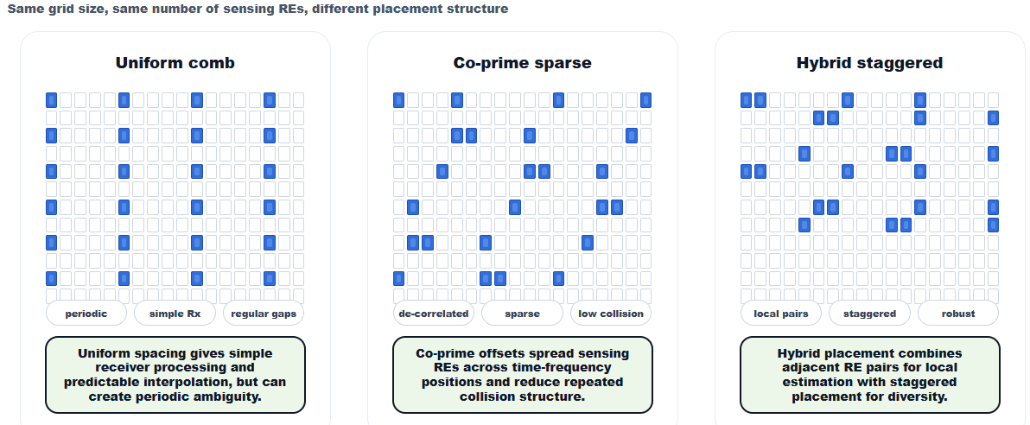
Figure 2.16-1: Candidate sensing RS RE pattern classes with the same grid size and same number of sensing REs.
For a candidate pattern $P$, the evaluation can be represented as
$$Score(P)=\frac{α}{{RMSE}_{range}(P)}+\frac{β}{{RMSE}_{Doppler}(P)}+γ\left(1-FalsePeakRate(P)\right)-δO(P)-ϵC(P),$$where ${RMSE}_{range}(P)$is the range estimation error, ${RMSE}_{Doppler}(P)$is the Doppler estimation error, $FalsePeakRate(P)$is the ambiguity or false-peak rate, $O(P)$is the RS overhead, and $C(P)$is the receiver or configuration complexity. This formulation shows that lower overhead alone is not sufficient. A pattern with low overhead may still be unsuitable if it creates high ambiguity or poor Doppler observability.
In simulation case S3, the hybrid staggered pattern consistently gives lower range RMSE than the uniform comb pattern over the evaluated RS-overhead range. At 6% RS overhead, the hybrid staggered pattern gives approximately 0.91 m range RMSE, compared with approximately 1.12 m for the uniform comb pattern and approximately 0.96 m for the co-prime sparse pattern. This supports studying structured non-uniform patterns instead of limiting the study to uniform comb patterns only.
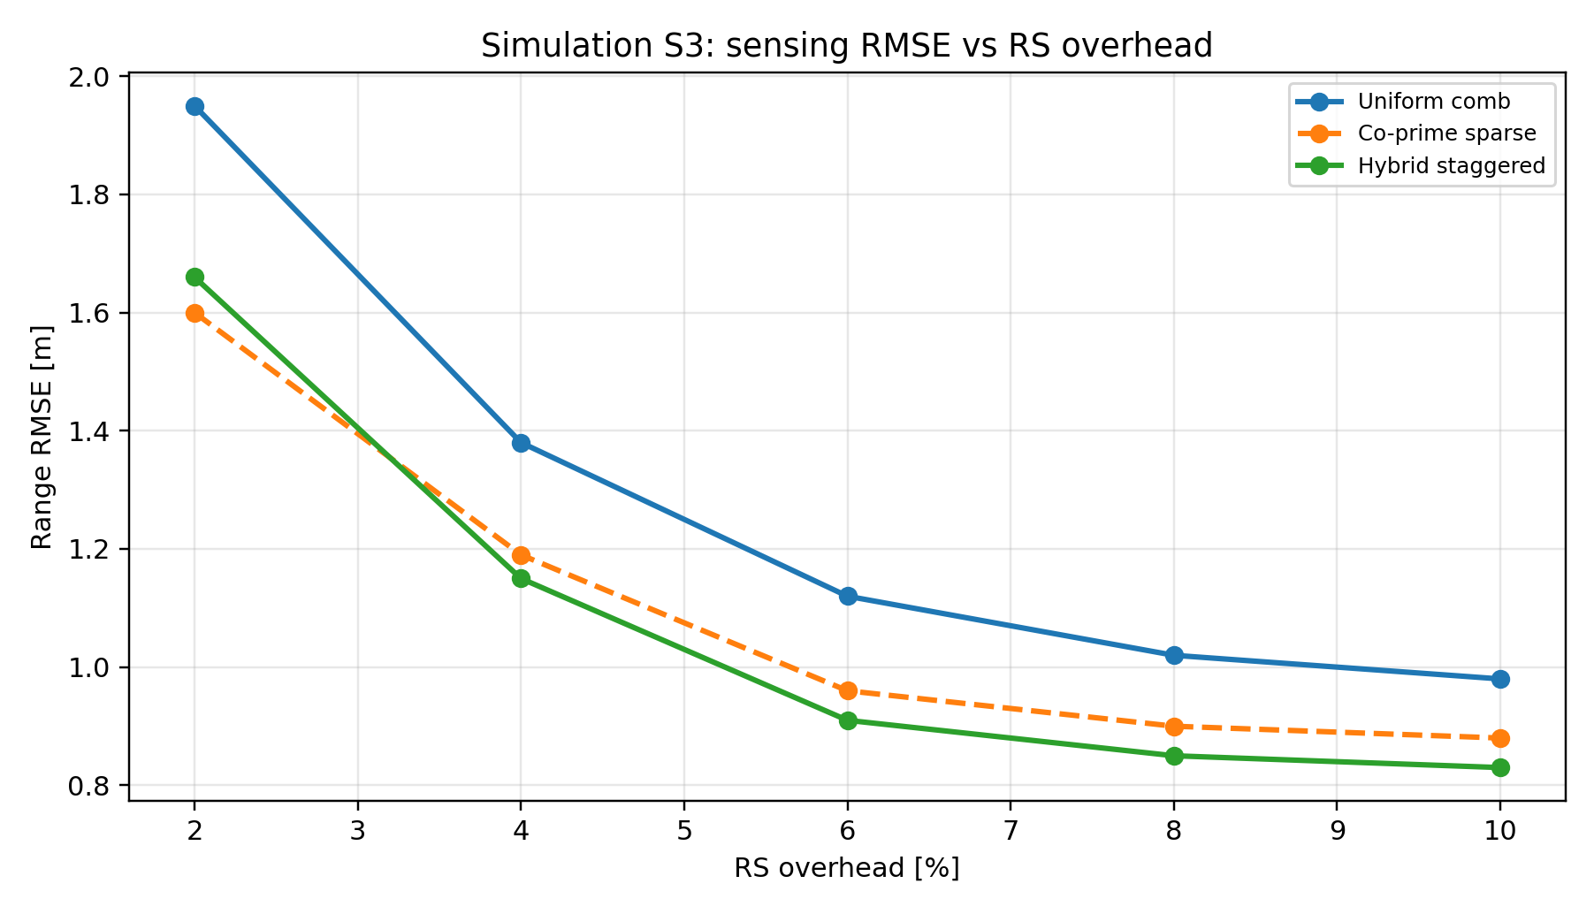
Figure 2.12-2: Simulation S3 range RMSE versus RS overhead for uniform comb, co-prime sparse and hybrid staggered RE patterns.
For Doppler-capable sensing, the RS configuration should also expose CPI duration and time-domain spacing. A single reception instance may support delay or power measurement, but Doppler or velocity estimation requires a coherent sequence across time. The velocity resolution approximately follows
$$Δv=\frac{λ}{2T_{CPI}},$$where $λ$is the carrier wavelength and $T_{CPI}$is the coherent processing interval. The maximum unambiguous velocity depends on the effective time spacing between sensing observations:
$$v_{unamb}=\frac{λ}{4T_{spacing}},$$where $T_{spacing}$is the minimum effective spacing between sensing snapshots. Therefore, communication RS periodicity with arbitrary gaps should not be assumed to be automatically suitable for Doppler sensing.
A longer CPI improves Doppler resolution, but CPI duration cannot be increased without limit. If the target moves significantly during the CPI, range migration can degrade sensing performance. A practical constraint can be expressed as
$$v_{max}T_{CPI}<ηΔR,$$where $v_{max}$is the maximum expected target velocity, $ΔR$is the range resolution and $η$is a design margin. This means CPI duration should be selected jointly with sensing bandwidth, expected target velocity and latency requirement.
Self-interference is another critical RS/resource design criterion for monostatic sensing. Monostatic sensing can provide geometry and coverage advantages, but simultaneous transmission and reception create self-interference. If the residual self-interference dominates the receiver, weak target echoes cannot be extracted. Pure communication RS reuse may not address this problem because communication RS structures are not designed for TX/RX leakage suppression or receiver saturation avoidance.
The receiver feasibility condition can be written as
$$P_{echo}>P_{noise}+P_{residual_SI}+M_{SI},$$where $P_{echo}$is the received target echo power, $P_{noise}$is receiver noise power, $P_{residual_SI}$is residual self-interference power and $M_{SI}$is the required self-interference margin. The residual self-interference can be represented as
$$P_{residual_SI}=P_{tx}-I_{iso}-C_{cancel},$$where $P_{tx}$is transmit power, $I_{iso}$is antenna/RF isolation and $C_{cancel}$is cancellation capability. If this condition cannot be satisfied, the sensing design may require pulse-like RS, TX/RX switching, sensing-specific gaps or non-simultaneous sensing intervals.
In the monostatic sensitivity calculation, increasing isolation from 65 dB to 80 dB expands the feasible transmit-power region, but it is not sufficient for all wide-area cases if cancellation capability is weak. This shows that self-interference should not be treated only as receiver implementation. It affects RS design, resource timing, transmission power and sensing mode feasibility.
Observation 14: Sensing RS design should be evaluated using joint sensing, coexistence and communication-reuse criteria because reused, enhanced and dedicated RS options have different trade-offs in ambiguity, Doppler support, PAPR, overhead, self-interference and communication impact.
Observation 15: Uniform RE patterns are useful baselines, but uniform comb placement can create periodic range ambiguity; structured non-uniform or hybrid staggered patterns can improve sensing RMSE for the same sensing RE budget.
Observation 16: Doppler-capable sensing requires explicit treatment of CPI duration, sensing RS time-domain density and target displacement because arbitrary communication RS gaps may not support reliable velocity estimation.
Observation 17: Self-interference resilience is a first-order requirement for monostatic ISAC and should be considered in RS/resource design rather than only as receiver implementation.
Proposal 14: RAN1 should study reused communication RS, enhanced communication RS and dedicated sensing RS using criteria including auto-correlation, sidelobe behavior, PAPR/cubic metric, unambiguous range, Doppler support, self-interference resilience, beam configurability, communication reuse potential, overhead and communication impact.
Proposal 15: RAN1 should study uniform, co-prime sparse and hybrid staggered RE patterns for sensing RS, with sensing accuracy, ambiguity, overhead and communication impact evaluated together.
Proposal 16: RAN1 should study CPI duration, time-domain RS spacing, velocity resolution, unambiguous velocity and target-displacement constraints for sensing measurements that include Doppler or velocity.
Proposal 17: RAN1 should study self-interference-related sensing RS and resource design aspects, including pulse-like RS, TX/RX switching, sensing-specific gaps, isolation assumptions and cancellation support.

2.13 Resource coexistence, CPI continuity and beam-related sensing operation
The issue is that sensing and communication share time, frequency, code and spatial resources. If sensing RS is always allocated dedicated resources, communication capacity can be degraded. If sensing and communication are fully overlapped without coordination, sensing accuracy and communication reliability can both degrade. Therefore, RAN1 should study not only sensing RS design, but also how sensing resources coexist with communication resources under realistic scheduling conditions.
Several multiplexing options can be considered. TDM separates sensing and communication in time and is robust when strong isolation is needed, but it can increase communication resource loss. FDM can allow sensing and communication to operate in different frequency regions, but RE-level FDM may reduce sensing RS power and introduce interference from neighboring communication REs. CDM can support multiple sensing entities on overlapping time/frequency resources, but it increases sequence and receiver-separation requirements. Beam-domain or SDM multiplexing can reduce communication loss when spatial isolation is high, but it depends on beam isolation, antenna capability and direction separation between communication area and target sensing area.
The multiplexing decision can be represented as
$$M^{*}=arg⁡\underset{M}{min⁡}\left[w_{1}L_{comm}(M)+w_{2}E_{sense}(M)+w_{3}I(M)+w_{4}C_{impl}(M)\right],$$
where $M$is the multiplexing method, $L_{comm}(M)$is communication loss, $E_{sense}(M)$is sensing error, $I(M)$is interference impact and $C_{impl}(M)$is implementation complexity. In the coexistence analysis, beam-domain multiplexing is effective when beam isolation exceeds approximately 20 dB for the interfering path. Otherwise, TDM or FDM with coordination is more robust. This indicates that multiplexing should be scenario dependent and should consider communication impact and sensing performance together.
Even after a multiplexing method is selected, real scheduling still requires collision rules. A sensing RS may overlap with PDSCH, PUSCH, CSI-RS, SRS, PRACH or control resources. Without collision semantics, the UE and aNB cannot have predictable behavior. Therefore, sensing resources should be associated with a collision priority or priority class. For low-latency beam assistance, sensing may be prioritized for a short event-driven window. For background sensing, communication should normally be prioritized.
Let $L_{comm}$denote the communication loss caused by muting, puncturing or rate matching, and let $G_{sense}$denote the expected sensing-assisted communication gain. Sensing priority is justified when
$$G_{sense}-L_{comm}>Γ_{prio},$$where $Γ_{prio}$is a configured or evaluated priority threshold. This avoids prioritizing sensing resources when the communication loss is larger than the expected sensing-assisted gain. In the resource model, short event-driven sensing windows created lower throughput loss than dense periodic sensing while preserving most of the beam-assistance gain. This supports priority-based activation for communication-assistance sensing.
CPI continuity is required when sensing measurements are processed coherently. Coherent processing across sensing snapshots assumes that the phase evolution is due to target Doppler, not unrelated radio configuration changes. Timing advance, transmit power, beam/TCI state, antenna port, BWP or frequency changes can introduce phase or amplitude jumps that corrupt Doppler estimation. Therefore, RAN1 should study a CPI continuity group. Resources in the same continuity group are expected to be processed coherently, and the network either restricts relevant changes, indicates when they occur, segments the CPI or provides compensation information.
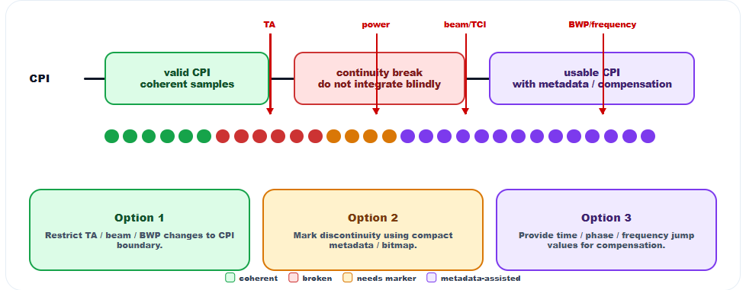
Figure 2.17-1: CPI continuity issue and possible handling options for TA, power, beam/TCI and BWP/frequency changes.
The coherent gain can be represented as
$$G_{coh}={∣\sum_{n=1}^{N}{a_{n}}e^{jϕ_{n}}∣}^{2},$$where $a_{n}$and $ϕ_{n}$are the amplitude and phase of the $n$-th sensing snapshot. If $ϕ_{n}$includes unknown discontinuities due to radio configuration changes, coherent gain decreases and Doppler estimation becomes biased. If discontinuities are known or compensated, coherent gain can be partly restored.
In simulation case S4, velocity RMSE increases with residual discontinuity when no continuity control is applied. At 100 Hz equivalent residual discontinuity, no continuity control gives approximately 0.41 m/s velocity RMSE, segmented processing gives approximately 0.28 m/s, and indication plus compensation gives approximately 0.18 m/s. This supports explicit CPI continuity handling for Doppler-capable sensing.
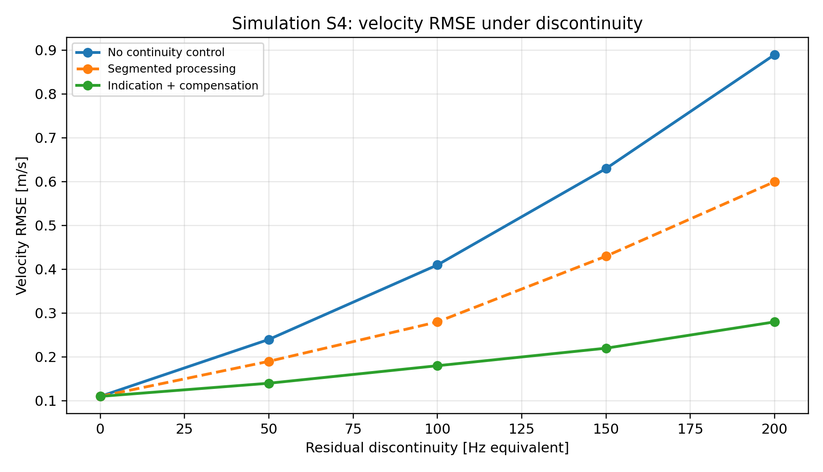
Figure 2.17-2: Simulation S4 velocity RMSE under residual discontinuity for no continuity control, segmented processing and indication plus compensation.
Beam-related sensing operation also requires separate treatment from communication-only beam management. Communication beam management usually searches for one or a small number of best UE communication beams. Sensing may require multiple beams because multiple targets, blockers or reflector paths can be relevant. The beam with maximum communication received power may not correspond to the best beam for observing the target sensing area. Therefore, sensing measurement and reporting should preserve beam association so the aNB can map sensing results to beam/TCI actions.
For $B$candidate beams and $K$targets, brute-force pairing can require $O(BK)$or $O(B^{2})$operations depending on Tx/Rx pairing. Sensing assistance can reduce this complexity by using prior range/angle constraints and reporting only the top-$K$ impacted or backup beams. In the beam simulation, top-2 backup beam reporting captured more than 94% of successful proactive switches. Top-1 was insufficient in rich reflection cases, while top-4 provided only limited additional gain but increased report size.
This supports a reporting design where multiple beam/TCI associations can be included when needed, but the number of reported entries is limited to control overhead. Such behavior is consistent with the BeamImpactReport direction, where the report contains the impacted beam/TCI list, recommended backup beam/TCI list, confidence and validity information.
Observation 18: No single multiplexing method is optimal for all ISAC scenarios because TDM, FDM, CDM and beam-domain multiplexing have different trade-offs in communication loss, sensing error, interference and implementation complexity.
Observation 19: Collision handling is necessary for sensing-communication coexistence because multiplexing options alone do not define UE/aNB behavior when sensing resources overlap with communication channels or reference signals.
Observation 20: CPI continuity metadata is required for Doppler-capable sensing measurements because timing, power, beam/TCI, antenna port and BWP/frequency changes can introduce discontinuities that are unrelated to target motion.
Observation 21: Sensing beam operation may require multiple beams that are not the same as the best communication beam, and the report should preserve beam association for beam/TCI adaptation.
Proposal 18: RAN1 should study TDM, FDM, CDM and beam-domain multiplexing for sensing and communication, including scenario-dependent suitability based on communication impact, sensing error, interference and overhead.
Proposal 19: RAN1 should study collisionPriority, DL rate matching/puncturing, UL muting, sensing suspension and event-driven sensing activation for overlapping sensing and communication resources.
Proposal 20: RAN1 should study CPI continuity groups and associated restriction, segmentation, indication or compensation mechanisms for timing, power, beam/TCI, antenna-port, BWP and frequency changes.
Proposal 21: RAN1 should study sensing beam measurement and reporting with multiple UE receiving beams or multiple beam/TCI associations for one sensing RS, including top-$K$ impacted and backup beam reporting.

3. Conclusion
Simulation methodology and evaluation metrics
Observation 1: A joint sensing-communication evaluation is necessary for 10.8.2 because a sensing option that improves range, velocity or detection performance may still be unsuitable if it increases reporting latency, RS/report overhead, false radio-action probability or communication outage.
Proposal 1: RAN1 should evaluate sensing-assisted communication features using both sensing-side and communication-side metrics, including at least reporting latency, sensing accuracy, detection probability, communication performance impact, RS/report overhead, false radio-action probability and victim communication outage.
Compact aNB-visible sensing information
Observation 2: For sensing-assisted communication, compact aNB-visible sensing reporting is needed because SF-only reporting can exceed the radio adaptation time budget, while raw or rich aNB reporting can create excessive UE processing and uplink overhead.
Proposal 2: RAN1 should study direct reporting of compact communication-assistance sensing information to aNB, with optional richer reporting to SF for non-real-time sensing fusion.
UE-aNB-SF procedure for communication assistance
Observation 3: For UE-involved sensing-assisted communication, aNB-controlled radio configuration and compact aNB-visible reporting provide better support for low-latency beam/CSI adaptation than SF-only configuration and reporting.
Proposal 3: RAN1 should study a UE-aNB procedure for communication assistance, including sensing RS configuration, measurement request, report configuration, reporting trigger, endpoint/latency-class indication and compact UE-to-aNB sensing measurement reporting.
Beam management as first sensing-assisted communication use case
Observation 4: Beam management is the most suitable first use case for sensing-assisted communication because both the sensing input and the communication action are radio-facing, low-latency and measurable using beam failure probability, CSI-RS overhead and beam-action latency.
Proposal 4: RAN1 should study sensing-assisted beam management as the primary usage scenario for communication assistance, including required sensing measurements, compact report content, confidence/validity information, candidate beam restriction, backup beam/TCI preparation and PHY-layer impact.
Communication-only beam management under dynamic blockage
Observation 5: Dynamic blockage creates a timing gap in communication-only beam management because the serving beam may degrade before measurement filtering, report triggering, network decision and beam switching are completed.
Proposal 5: RAN1 should study sensing-triggered beam candidate restriction and backup beam/TCI preparation to reduce reactive beam-management delay and CSI-RS sweeping overhead under dynamic blockage.
BeamImpactReport for sensing-assisted beam management
Observation 6: A beam-management-specific sensing report is more efficient and more actionable than a generic sensing report for low-latency radio adaptation because the aNB needs impacted beam/TCI, backup beam/TCI, confidence and validity information rather than raw sensing data or full object semantics.
Proposal 6: RAN1 should study BeamImpactReport for sensing-assisted beam management, including impacted beam/TCI, recommended backup beam/TCI, impact type, impact probability, time-to-impact, validity time, confidence metric and sensing resource association.
Purpose-tagged report container and endpoint split
Observation 7: Purpose, endpoint and latency class are necessary report semantics because the same sensing measurement has different radio value depending on the consumer, assisted feature and required radio-action timing.
Proposal 7: RAN1 should study reportPurpose, reportEndpoint, latencyClass, reportLevel, measurementQuantityBitmap and triggerType as part of sensing measurement reporting for communication assistance.
L1, MAC and higher-layer carrying of sensing reports
Observation 8: Different sensing reports require different carrying options because payload size, latency requirement and reliability requirement are not uniform across beam assistance, CSI assistance, interference handling and sensing fusion.
Proposal 8: RAN1 should study L1, MAC and higher-layer carrying for sensing reports, with compact low-latency communication-assistance reports considered for L1/MAC and richer sensing reports considered for MAC, RRC or higher-layer transport.
Confidence, validity time and non-ideal-factor indicators
Observation 9: Confidence, validity time and non-ideal-factor indicators are necessary for sensing-assisted communication because stale, discontinuous or low-confidence sensing reports can cause incorrect beam/TCI, CSI-RS, scheduling or interference-mitigation actions.
Proposal 9: RAN1 should study confidence metric, validity time, report age handling and non-ideal-factor indicators as part of sensing measurement reporting for communication assistance.
Sensing RS design criteria
Observation 10: Sensing RS design should be evaluated using joint sensing, coexistence and communication-reuse criteria because reused, enhanced and dedicated RS options have different trade-offs in ambiguity, Doppler support, PAPR, overhead, self-interference and communication impact.
Proposal 10: RAN1 should study reused communication RS, enhanced communication RS and dedicated sensing RS using criteria including auto-correlation, sidelobe behavior, PAPR/cubic metric, unambiguous range, Doppler support, self-interference resilience, beam configurability, communication reuse potential, overhead and communication impact.
RE pattern classes and ambiguity
Observation 11: Uniform RE patterns are useful baselines, but uniform comb placement can create periodic range ambiguity; structured non-uniform or hybrid staggered patterns can improve sensing RMSE for the same sensing RE budget.
Proposal 11: RAN1 should study uniform, co-prime sparse and hybrid staggered RE patterns for sensing RS, with sensing accuracy, ambiguity, overhead and communication impact evaluated together.
CPI duration, Doppler resolution and target displacement
Observation 12: Doppler-capable sensing requires explicit treatment of CPI duration, sensing RS time-domain density and target displacement because arbitrary communication RS gaps may not support reliable velocity estimation.
Proposal 12: RAN1 should study CPI duration, time-domain RS spacing, velocity resolution, unambiguous velocity and target-displacement constraints for sensing measurements that include Doppler or velocity.
Self-interference resilience for monostatic sensing
Observation 13: Self-interference resilience is a first-order requirement for monostatic ISAC and should be considered in RS/resource design rather than only as receiver implementation.
Proposal 13: RAN1 should study self-interference-related sensing RS and resource design aspects, including pulse-like RS, TX/RX switching, sensing-specific gaps, isolation assumptions and cancellation support.
Multiplexing sensing RS with communication resources
Observation 14: No single multiplexing method is optimal for all ISAC scenarios because TDM, FDM, CDM and beam-domain multiplexing have different trade-offs in communication loss, sensing error, interference and implementation complexity.
Proposal 14: RAN1 should study TDM, FDM, CDM and beam-domain multiplexing for sensing and communication, including scenario-dependent suitability based on communication impact, sensing error, interference and overhead.
Collision handling, priority and rate matching
Observation 15: Collision handling is necessary for sensing-communication coexistence because multiplexing options alone do not define UE/aNB behavior when sensing resources overlap with communication channels or reference signals.
Proposal 15: RAN1 should study collisionPriority, DL rate matching/puncturing, UL muting, sensing suspension and event-driven sensing activation for overlapping sensing and communication resources.
CPI continuity metadata and compensation
Observation 16: CPI continuity metadata is required for Doppler-capable sensing measurements because timing, power, beam/TCI, antenna port and BWP/frequency changes can introduce discontinuities that are unrelated to target motion.
Proposal 16: RAN1 should study CPI continuity groups and associated restriction, segmentation, indication or compensation mechanisms for timing, power, beam/TCI, antenna-port, BWP and frequency changes.
Beam-related sensing operation for multiple targets
Observation 17: Sensing beam operation may require multiple beams that are not the same as the best communication beam, and the report should preserve beam association for beam/TCI adaptation.
Proposal 17: RAN1 should study sensing beam measurement and reporting with multiple UE receiving beams or multiple beam/TCI associations for one sensing RS, including top-$K$ impacted and backup beam reporting.
Measurement request and search-space restriction
Observation 18: Sensing measurement request information can reduce UE processing burden, report payload and false detections by restricting the search space to communication-relevant range, Doppler, angle and beam regions.
Proposal 18: RAN1 should study sensing measurement request content including sensing mode, RS configuration, requested measurement quantities, sensing range, Doppler range, angle/beam range, reporting threshold, confidence threshold and report endpoint.
Report overhead reduction
Observation 19: Report overhead can be reduced by configuring measurement quantities, report extents and threshold-based reporting instead of requiring the UE or sensing receiver to report all detectable sensing components.
Proposal 19: RAN1 should study overhead-reduction mechanisms for sensing measurement reporting, including configured range/Doppler/angle extents, measurementQuantityBitmap, threshold-based reporting and top-$K$ reporting.
Power control and power information for sensing
Observation 20: Sensing signal power control should consider sensing mode, target-scattered path power, self-interference, receiver dynamic range and communication coexistence, rather than only communication-link RSRP.
Proposal 20: RAN1 should study sensing signal transmission power control from the perspective of sensing mode, including target-channel power, sensing power offset, repetition-based processing gain, power boosting and simultaneous communication/sensing power split.
Timing advance and sensing activation aspects
Observation 21: Timing advance, sensing Tx/Rx node selection and sensing activation affect sensing geometry, SNR, interference, beam alignment and reporting latency, and therefore require radio-facing study from a RAN1 perspective.
Proposal 21: RAN1 should study the necessity and applicability of timing advance for sensing, together with radio-facing metrics for sensing Tx/Rx node selection and activation/deactivation, including distance to target sensing area, beam availability, received sensing power, interference condition, capability, load, activation delay, duration and collision priority.

4. References
RP-251881, New SID: Study on 6G Radio.
R1-2602592, Summary #4 on integration with communication for ISAC, Moderator (Xiaomi).

